 INFORMATION COMMUNICATION TECHNOLOGIES
- ICT
Information and Communication Technology or “ICT,” includes products that store, process, transmit, convert, duplicate, or receive electronic information. ... Electronic textbooks, instructional software, email, chat, and distance learning programs are also examples of ICT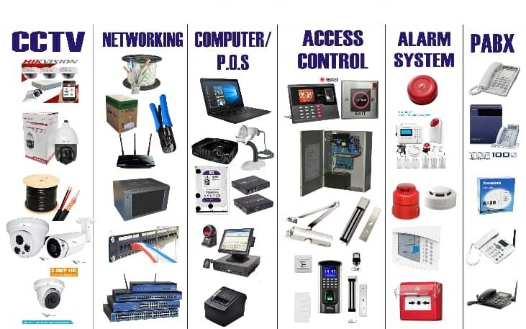

- HISTORY OF COMPUTER
The computer has evolved from a large-sized to simple calculating machine to a smaller but much more powerful machine. The evolution of computer to the current state is defined in terms of the generations of computer. Each generation of computer is designed based on a new technological development. Currently, there are five generations of computer.

- 1st Generation Computers (1940 to 1956)
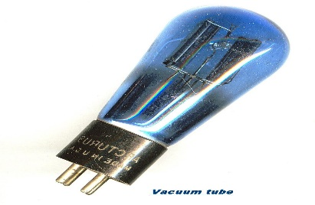
- The first generation of computers used vacuum tubes for circuitry and magnetic drums for memory also big in size to occupy the room.
- The input to the computer was through punched cards. The output was displayed as printouts.
- The first generation computers used a large number of vacuum tubes and thus generated a lot of heat.
- They consumed a great deal of electricity and were expensive to operate.

- 2nd Generation Computers (1956 to 1963)
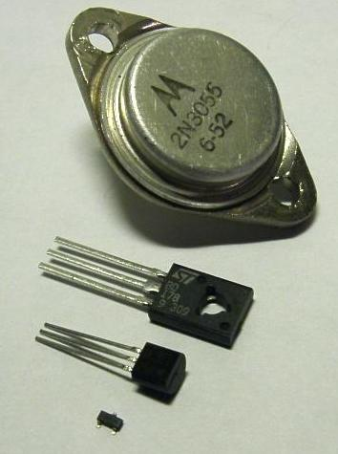
- In hardware Technology Transistors replaced the vacuum tubes of the first generation of computers.
- Transistors are smaller in size compared to vacuum tubes, thus, the size of the computer was also reduced.
- Transistors allowed computers to become smaller, faster, cheaper, energy efficient and reliable.
- The second generation computers used magnetic core technology for memory. They used magnetic tapes and magnetic disks for secondary storage.
The input was still through punched cards and the output using printouts.

- 3rd Generation Computers (1964 to 1971)
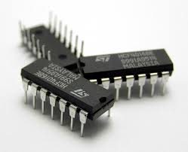
- The third generation computers used the Integrated Circuit (IC).
- In an IC chip, multiple transistors are placed on a silicon chip.
- The use of IC chip increased the speed and the efficiency of computer
- The keyboard and monitor were used to interact with the third generation computer, instead of the punched card and printouts.
- The third generation computers used less power and generated less heat than the second generation computers

- 4th Generation Computers (1971 to present)
- Hardware Technology uses the Large Scale Integration (LSI) and the Very Large Scale Integration (VLSI) technology.
- Thousands of transistors are integrated on a small silicon chip using LSI technology.
- VLSI allows hundreds of thousands of components to be integrated in a small chip.
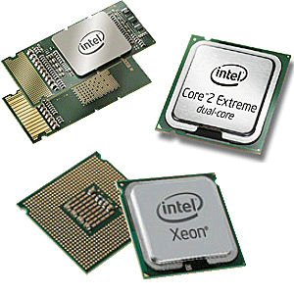
- This period is marked by the development of microprocessor. Microprocessor is a chip containing millions of transistors and components, and, designed using LSI and VLSI technology. The fourth generation computers are also portable and more reliable.
- This generation of computers gave rise to Personal Computer (PC).
- Several new operating systems like the MS-DOS and MS-Windows developed during this time.
- This generation of computers supported Graphical User Interface (GUI). GUI is a user-friendly interface that allows user to interact with the computer via menus and icons
- Computers became widely available for commercial purposes. Personal computers became available to the home user.
- Examples The Intel 4004 chip was the first microprocessor

- 5th Generation Computers (Present and Next)
- The ﬁfth generation computers are based on Artiﬁcial Intelligence (AI). They try to simulate the human way of thinking and reasoning.
- The fifth generation computers use Super Large Scale Integrated (SLSI) chips that are able to store millions of components on a single chip.
- Artiﬁcial Intelligence includes areas like
- Robotics, etc.

- COMPUTER TYPES

Computers can be classified, or typed, in many ways. Some common classifications of digital computers are summarized below.

- SUPERCOMPUTER
- ​MAINFRAME COMPUTER
- ​MINICOMPUTER
- ​MICROCOMPUTER

- SUPERCOMPUTER
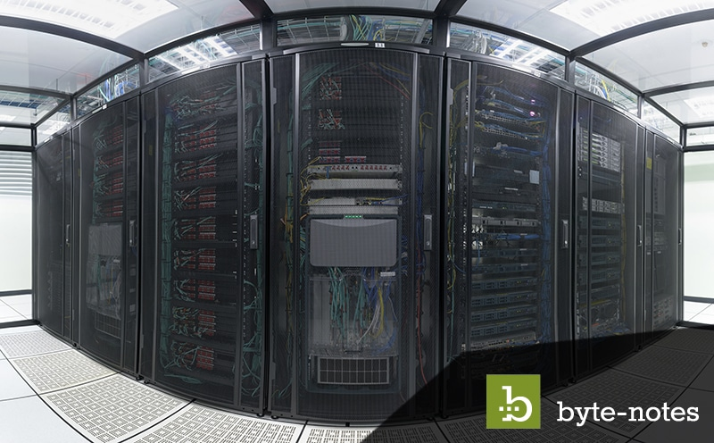
The most powerful computers in terms of performance and data processing are the Supercomputers. These are specialized and task specific computers used by large organizations. These computers are used for research, Exploration purposes, like NASA uses supercomputers for launching space shuttles, controlling them and for Space exploration purpose.

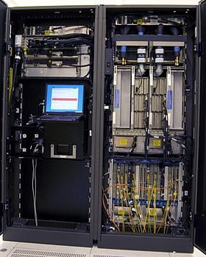
- MAINFRAME COMPUTER

Although Mainframes are not as powerful as supercomputers, but certainly they are quite expensive nonetheless, and many large firms & government organizations uses Mainframes to run their business operations. The Mainframe computers can be accommodated in large air-conditioned rooms because of its size. Super-computers are the fastest computers with large data storage capacity, Mainframes can also process & store large amount of data. Banks educational institutions & insurance companies use mainframe computers to store data about their customers, students & insurance policy holders.

- MINI COMPUTER

Minicomputers are used by small businesses & firms. Minicomputers are also called as “Midrange Computers”. These are small machines and can be accommodated on a disk with not as processing and data storage capabilities as super-computers & Mainframes. These computers are not designed for a single user. Individual departments of a large company or organizations use Mini-computers for specific purposes. For example, a production department can use Mini-computers for monitoring certain production process.

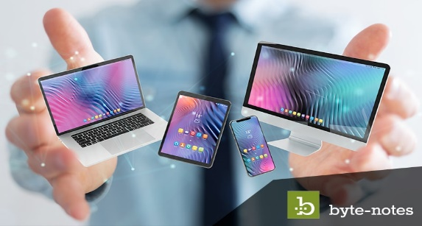
- MICROCOMPUTER
Desktop computers, laptops, personal digital assistant (PDA), tablets & smartphones are all types of microcomputers. The micro-computers are widely used & the fastest growing computers. These computers are the cheapest among the other three types of computers. The Micro-computers are specially designed for general usage like entertainment, education and work purposes. Well known manufacturers of Micro-computer are Dell, Apple, Samsung, Sony & Toshiba.
Desktop computers, Gaming consoles, Sound & Navigation system of a car, Netbooks, Notebooks, PDA’s, Tablet PC’s, Smartphones, Calculators are all type of Microcomputers.

- COMPUTER MEMORY
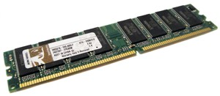
Computer memory is any physical device capable of storing information temporarily, like RAM (random access memory), or permanently, like ROM (read-only memory). Memory devices utilize integrated circuits and are used by operating systems, software, and hardware.

- RAM
RAM (pronounced ram) is an acronym for random access memory, a type of computer memory that can be accessed randomly; that is, any byte of memory can be accessed without touching the preceding bytes. RAM is found in servers, PCs, tablets, smartphones and other devices, such as printers.
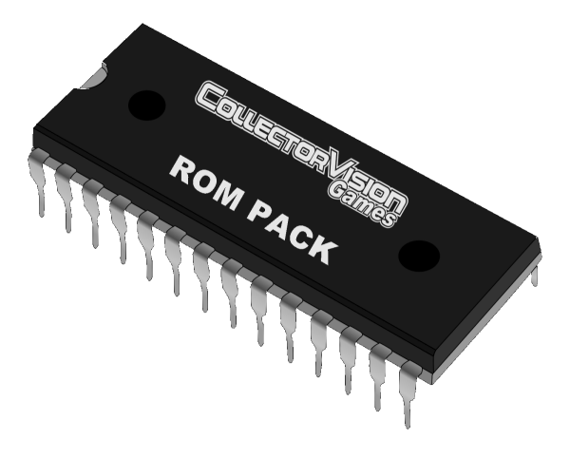
- ROM
Read-only memory (ROM) is a type of storage medium that permanently stores data on personal computers (PCs) and other electronic devices. It contains the programming needed to start a PC, which is essential for boot-up; it performs major input/output tasks and holds programs or software instructions
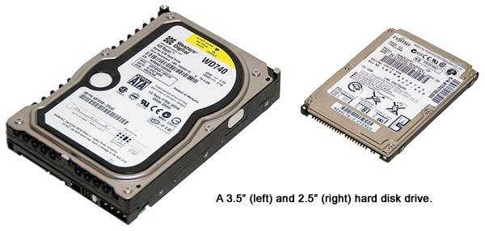
- STORAGE
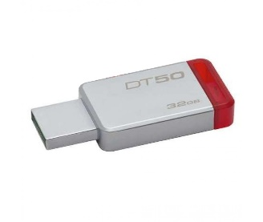
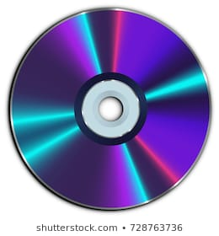
Storage is a process through which digital data is saved within a data storage device by means of computing technology. Storage is a mechanism that enables a computer to retain data, either temporarily or permanently. Storage may also be referred to as computer data storage or electronic data storage.
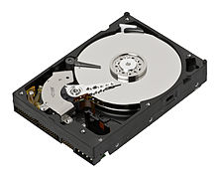

- Hard disk
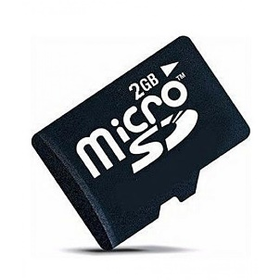
- USB
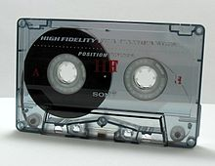
- SSD
- Optical Disk
- Floppy Disk
- Magnetic Tape
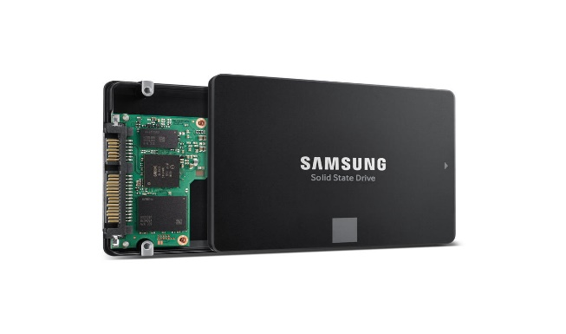
- Cloud Storage
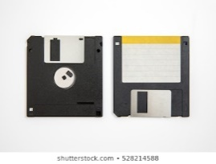
- Memory Card

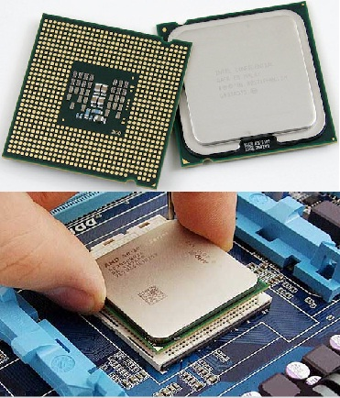
CPU
Central processing unit (CPU) is the central component of the Computer System. Sometimes it is called as microprocessor or processor. It is the brain that runs the show inside the Computer. All functions and processes that is done on a computer is performed directly or indirectly by the processor. Obviously, computer processor is one of the most important element of the Computer system. CPU is consist of transistors that receives inputs and produces output. Transistors perform logical operations which is called processing. It is also, scientifically, not only one of the most amazing parts of the PC, but one of the most amazing devices in the world of technology.

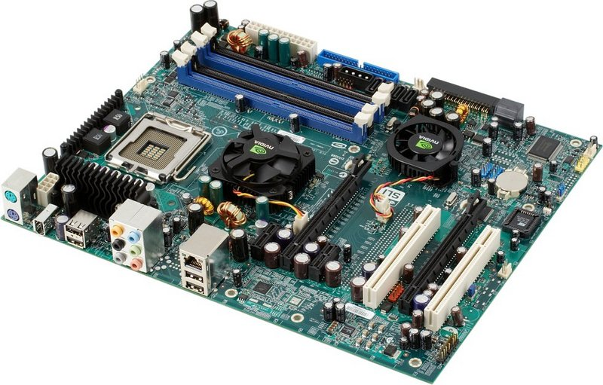
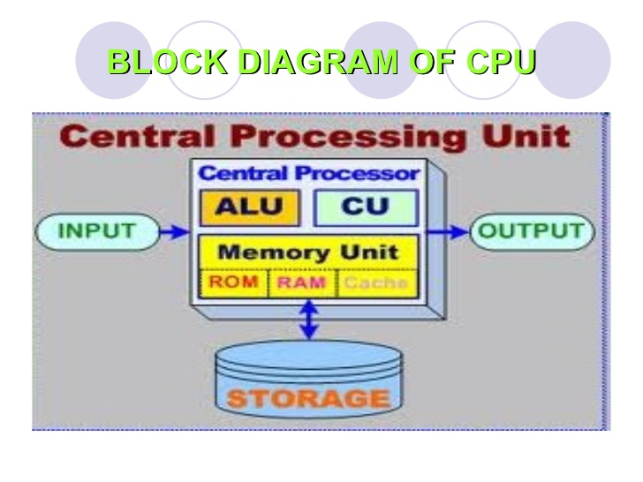
Central Processing Unit (CPU) consists of the following features −
- CPU is considered as the brain of the computer.
- CPU performs all types of data processing operations.
- It stores data, intermediate results, and instructions (program).
- It controls the operation of all parts of the computer.
CPU itself has following three components.
- Memory or Storage Unit
- Control Unit
- ALU(Arithmetic Logic Unit)

Memory or Storage Unit
This unit can store instructions, data, and intermediate results. This unit supplies information to other units of the computer when needed. It is also known as internal storage unit or the main memory or the primary storage or Random Access Memory (RAM).
Its size affects speed, power, and capability. Primary memory and secondary memory are two types of memories in the computer. Functions of the memory unit are −
- It stores all the data and the instructions required for processing.
- It stores intermediate results of processing.
- It stores the final results of processing before these results are released to an output device.
- All inputs and outputs are transmitted through the main memory.

Control Unit
This unit controls the operations of all parts of the computer but does not carry out any actual data processing operations.
Functions of this unit are −
- It is responsible for controlling the transfer of data and instructions among other units of a computer.
- It manages and coordinates all the units of the computer.
- It obtains the instructions from the memory, interprets them, and directs the operation of the computer.
- It communicates with Input/Output devices for transfer of data or results from storage.
- It does not process or store data.

ALU (Arithmetic Logic Unit)
This unit consists of two subsections namely,
- Arithmetic Section
- Logic Section

Arithmetic Section
Function of arithmetic section is to perform arithmetic operations like addition, subtraction, multiplication, and division. All complex operations are done by making repetitive use of the above operations.

Logic Section
Function of logic section is to perform logic operations such as comparing, selecting, matching, and merging of data.

